Press Release
Thursday, June 4, 2015

Grant Thornton "Insurance breakfast event" at Intercontinental Hotel

On Thursday, June 4, maintaining its commitment to rendering timely and meaningful information to business leaders, Grant Thornton, for the first time, held a breakfast event devoted to the recent developments in the insurance segment. The "Insurance breakfast event" was designed in order to offer the attendees a unique opportunity for communication and exchange of opinions and ideas between the insurance segment executives at a short-term, audience restricted event – a creative start to a business day.

The attendees were welcomed by Mr. Vasilis Kazas, the Managing Partner of Grant Thornton, who thanked the audience for responding to the invitation and made a brief reference to the significance of the current period as well as the following years to the insurance market development.

Presentations, focusing on the current challenges facing the segment were made by Mr. Spiros Mavrogalos, CEO at Ethniki Asfalistiki and Mr. Costas Bertsias, Deputy CEO & Managing Director, European Union Minettas Insurances.

Finally, Grant Thornton Partners, Mr. Yiannis Leos and Mr. Vassilis Monogios and Senior Manager of Grant Thornton UK, Mr. Abraham Ashraf reported on the major issues regarding Solvency II and IFRS implementation, ORSA processes & activities as well as Capital Management planning.

The “Insurance breakfast event” was attended by over 40 top executives of the domestic insurance companies and was followed by a light meal and a discussion on the presented issues.
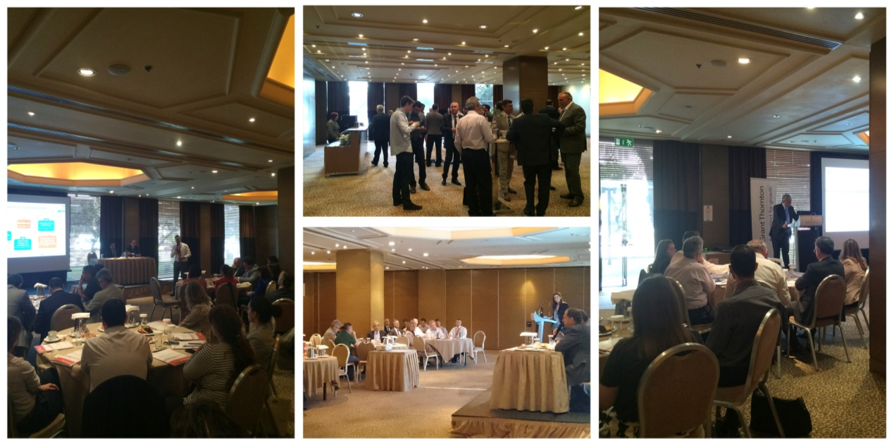

For more information, please contact:

Marketing & Business Development Department

T: 210 72 80 069-70

Φ: 210 72 12222

E: marketing@gr.gt.com

