News release

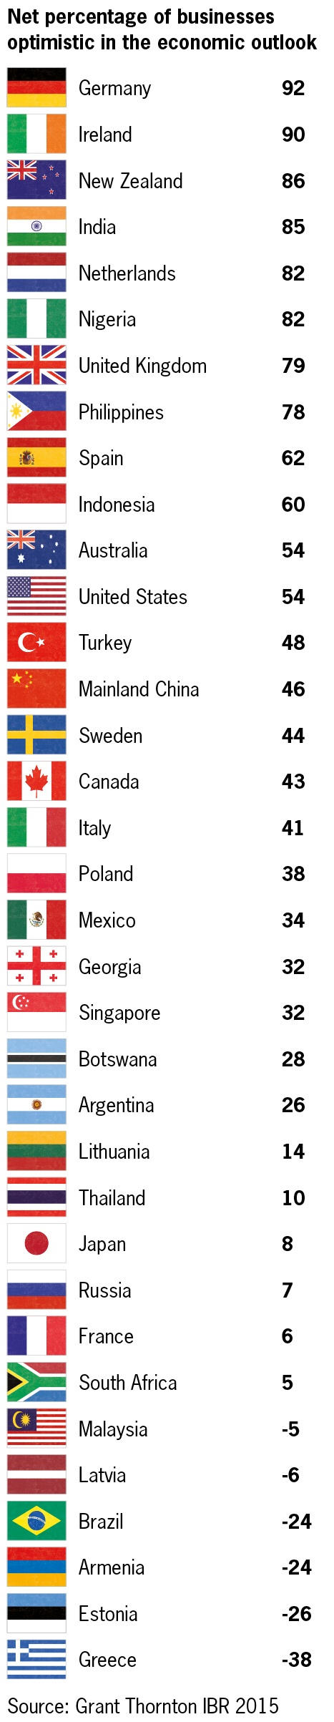
Beside the uncertainty, business optimism in Europe hits a fresh high

Business optimism in Europe has surged ahead to its highest level in five years, despite ongoing uncertainty over the future of Greece. According to the Grant Thornton International Business Report (IBR), a quarterly global survey of 2,580 businesses, economies in Europe and beyond, are buoyed by improving business growth expectations and are looking beyond the problems in Greece.

Business optimism around the world jumped in the last quarter, from net 33% to 45%. Confidence in the European Union (EU) increased by 20 percentage points over the quarter to reach 58%, beating pre-crisis highs. Optimism in the eurozone leapt from 34% to 54% over the same period. Germany is now the most optimistic economy in the IBR at 92% (Q1= 59%). On the other hand, Greece has the highest rates of pessimism in the European Union (-38% measured in optimism levels). Businesses in the UK, Spain, France and Italy also posted significant improvements in their outlook.

Vassilis Kazas, Managing Partner of Grant Thornton Greece, commented:
“Business confidence in Europe is proving extremely resilient in the first half of 2015. In a period where financial markets and politicians are facing significant difficulties, businesses appear to be looking past the issue. Supported by strong revenue and profit growth expectations, businesses are forecasting a strong 12 months”.

However, in Greece the situation is completely different. The revenue expectations for the next 12 months have fallen by 24% from the first quarter, while in the EU the respective percentage dropped by only 6%. Significant decline was also observed in employment expectations in Greece, by 12% from the 1st to the 2nd quarter, while the perception of enterprises regarding the lack of finance deteriorated, with 62% of Greek businesses to trouble strongly in Q2 (44%).

No doubt there is also a feeling among business leaders that they have seen this all before. Europe's banks have increased their capital buffers, while other previously troubled economies such as Ireland, Spain and Portugal are growing. That said, business leaders must make sure they keep contingency plans robust and avoid being caught out in any unexpected future development.

Regarding business development initiatives, the noteworthy fact is that Greek companies have higher odds ratios to develop or launch a new product or service (40% of surveyed firms), in contrast to the European Union and Southern Europe, where this probability appears significantly smaller (30% in both regions). A total 63% of companies surveyed say they would expand their business either abroad or domestically, while only 7% of them would proceed to a merger or acquisition of a business.

Optimism in Europe is underpinned by exceptional levels of expectation on revenues: net 52% of businesses expect growth over the next 12 months, the highest since 2008. Germany (91%) leads the way, supported by France, Spain and Ireland, all of which reported increases in expectations. There is also good news for workers in Europe, with net 70% of companies planning to offer their employees pay rises in the next year, up from 55% in the previous quarter.

Global outlook

Europe is not alone in its sentiment that the next 12 months will be good for business. The three largest economies in the world all saw sharp upswings in optimism: the United States (up 11pp to 54%), China (up 8pp to 46%) and Japan (up 25pp to 8%) also report an uplift in levels of optimism. However, the picture is not universally positive. Brazil, one of the leading emerging economies of the last decade, is seeing a rapid deterioration in confidence and expectations. Over the past year optimism has fallen 56pp to -24%, the biggest negative swing reported by a major economy in the survey over this period. Revenue growth expectations there have plummeted by 29pp to 28% over the same period.

Meanwhile in the Eurozone economic data has been more clearly positive. Q1 was the fastest quarter of growth since 2013Q2, and signs point towards further acceleration in rest of the year. The weaker euro is gradually improving labour market and easing fiscal constraints all pushing GDP growth towards 1.6% in 2015 and close to 2% in 2016.

Most major Eurozone risks have diminished, but Greece remains a sore point. Situation changing by the day/hour, but our central view remains Greece remaining in Eurozone. A possible “Grexit” would have implications for high-debt economies through contagion effects.

– ends –

For more info please contact:
Marketing & Business Development Dpt.
E marketing@gr.gt.com
T 210 72800 69-70
W www.grant-thornton.gr

Notes to editors
The Grant Thornton International Business Report (IBR) provides insight into the views and expectations of more than 10,000 businesses per year across 36 economies. This unique survey draws upon 22 years of trend data for most European participants and 11 years for many non-European economies. More information: www.grantthornton.global

Questionnaires are translated into local languages with each participating country having the option to ask a small number of country specific questions in addition to the core questionnaire. Fieldwork is undertaken on a quarterly basis, primarily by telephone. IBR is a survey of both listed and privately held businesses. The data for this release are drawn from interviews with more than 2,500 chief executive officers, managing directors, chairmen or other senior executives from all industry sectors conducted in May 2015.

“Grant Thornton” refers to the brand under which the Grant Thornton member firms provide assurance, tax and advisory services to their clients and/or refers to one or more member firms, as the context requires. Grant Thornton International Ltd (GTIL) and the member firms are not a worldwide partnership. GTIL and each member firm is a separate legal entity. Services are delivered by the member firms. GTIL does not provide services to clients. GTIL and its member firms are not agents of, and do not obligate, one another and are not liable for one another’s acts or omissions.

